Terrorism Analysis

With

Insights

Submitted

by

**Vedhas Kharche**

Under the guidance of

**Dr. Sylvester Fernandes,**

**Forsk Coding School**

10,August 2020

**Table of content**

* **Project overview**
* **Introduction**
* **About project**
* **work for project and Implementation**
* **Results**
* **Conclusion**
* **Acknowledgements**
* **References**
* **Biography**

**Project overview**

The project is about terrorism analysis with insight and which has some requirements like it should be able to run the Python file from the command line and it should open itself in a web browser and after completetation of work it should close also from browser,second one is it should also directly close the script running in the background. The web page contains a two tool, Map and chart tool. In the map tool generate a Scatter world Map and India Map with markers for highlighting the latitude and longitude where the incident happened based on combinations of Month, Day, Attack Type, Region, Country and City and also able to select any day,month,Country, Region, City and based on that the we shown change in world map and India map,also able to select the multiple value of all thing and when we touch the map it is given all information like which region,country,latitude,longitude ect we touch,it is called hovering the data. Option to have animation to Play and Pause for the Years and should be able to filter data based on year range.In Chart tool we showed Stacked Line Chart images of the frequency of terrorist incidents each year for both the world and India. The chart tool should be able to select the different type of group like Country Attacked, Region, Target Nationality, Target Type, Type of Attack, Weapon Type, Terrorist Organisations or also be able to search based on the selected Group or be able to Filter data based on the Year.both the map and chart have follow rule overview first, zoom and filter, given details on demand.

**Introduction**

1. **About the project**

For this project we using a Python with Dash framework which use many other laybaries like pandas,plotly,webbrowser and displaying data visualization of global terrorism using a dataset of approximately 1,90,000 records.In project we use Two types of visualization**,**first is Map tool which given the World Map and India Specific Map and second is Chart tool which given Area chart for world data and also for only India data which shown the number of incident happend to every year.In world Map UI ,There are seven dropdown UI each of which plays the function of a filter for the world map so Dropdown UIs are:

1. Month
2. Date
3. Region
4. Country
5. Province/State
6. City
7. Attack-Type

After creating this seven UI we use filtering on that UI using the callbacks concept like without select the month can not show the data of date and same for region and country,first you have to select Region then countries of that particular selected region.similarly for state and city.create the range slider for year so when we change in the slider according that map also change .now we create the legend of attack type which showen side of map and given different color to the attack type.

For the India Specific Map we have disable value of region and country so, The Region is South Asia and the country is India. For other UI like month,date apply filtering same as in world map. The legend is the same as the World Map.

Next we have Chart Tool which has two type,first is world chart tool and second is India chart tool.Chart Tool UI contain

1. Incidents Grouped By- Region(by default)
2. Search Box Filter
3. Area Chart

For the world chart tool we have one dropdown which contains multiple group regions,attack type,weapon type,nationality ,organization, country attack and using search tool searches for the selected dropdown filter's content, whether it is contained in it or not. If it yields results then they are shown, if not the original legend is shown that has been selected from the dropdown.

India Area Chart has two decibel values region and country as region 'South Asia' selected and for country 'India'. If the user searches for something then it is shown that graph otherwise it shows the region's graph.

**My**  **project work and Implementation**

Before starting the project I read the user expectations for project and then started my work on it..First step is i need to convert text file to csv file,for that write the code in spyder and using pandas library,which is used for data analysis convert text file into csv file.

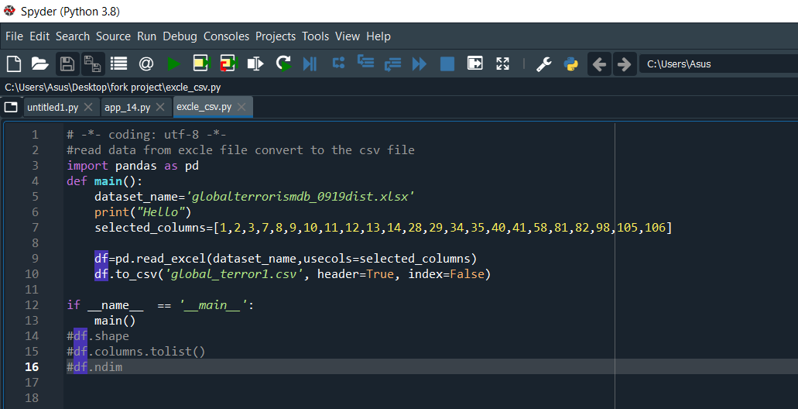

After creating csv file now I starting the coding other expectations for project and for that use the dash framework which is building web application and import all the necessary libraries in code which require for complete the project.UI Expectation for taking input from the user and UI Expectation for the output,so for that import dash_html_component as html for use html in python and import dash_core_component as dcc for create dropdowns,graphs,range slider and Tabs.use the define function as def for different functionality.

Create a define function(def) for loading the data which is required for making a webpage. then create another def for html at which i make tabs, dropdowns,graphs,range slider and search buttons the same for others also.in fig you show that i use global which is used for globalize the data

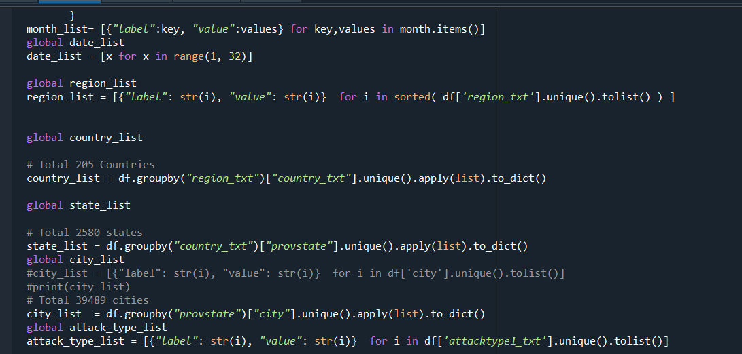

In project code first in def define data and than make the seven dropdown for different datas like month,days,region,country,state,attack type.in next step filter the all the data using callbacks for that use library from dependencies import Input,Output which is help to filter data when we select the month than date is shown in dropdown other wise no data found for date same for region and country.next we want to select multiple value in dropdown so we just use multi=True in dropdown.upload the world map using data we again use the callbacks method.than create legend for attack type.then create the two tabs map tool and chart tool which have two subtabs world map tool and indian map tool.

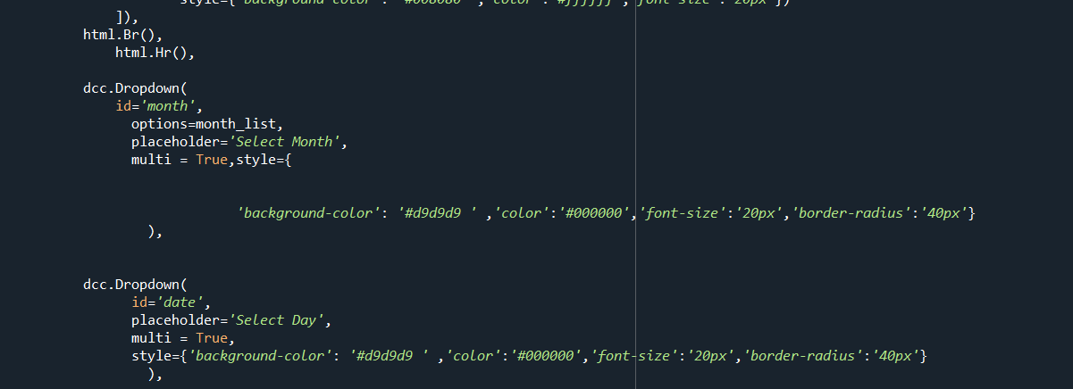

For map tool UI first we create world map tool which connected with dropdown when i change

The value according to that my world map also change and in India map tool we have two disebal value for region is South Asia and for country is India which change also shown in world map when i selected india map tool this is fulfill by using callbacks and when i change year slider according to that world map also given changes.

For chart too UI we create world data graph with all year in data file.for that create dropdown which have different group like region,attack type,organization,country attack,weapon attack,type of nationality and for selected group we search particular data from search input which given particular graph of that search data and also change the year from slider which given changeable graph of year. When selecting India tool the region and country have default value which is south asia and India and it is only given the India graph and south asia graph as output here also we change year using year slider which gives implementation on graph.

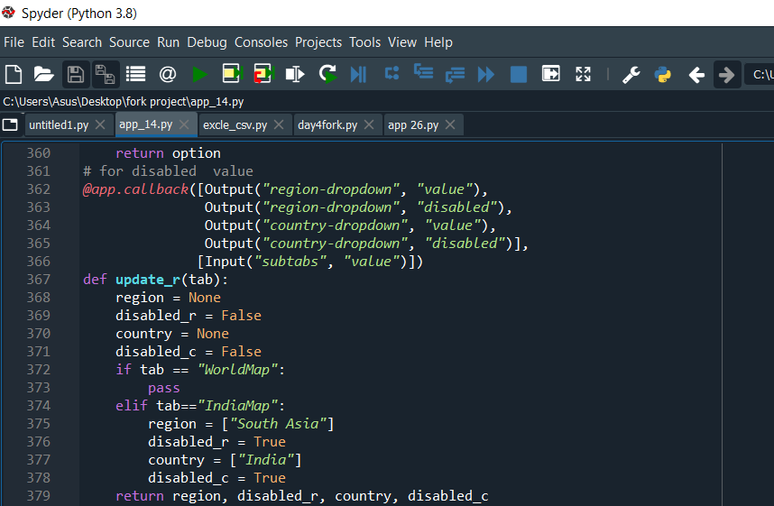

And lastly, using css makes the web page more attractive.for all this implementation without forsk coding school not possible i done my project because of their daily encouragement and support.

**Results**

1. **Dropdown and range slider created**

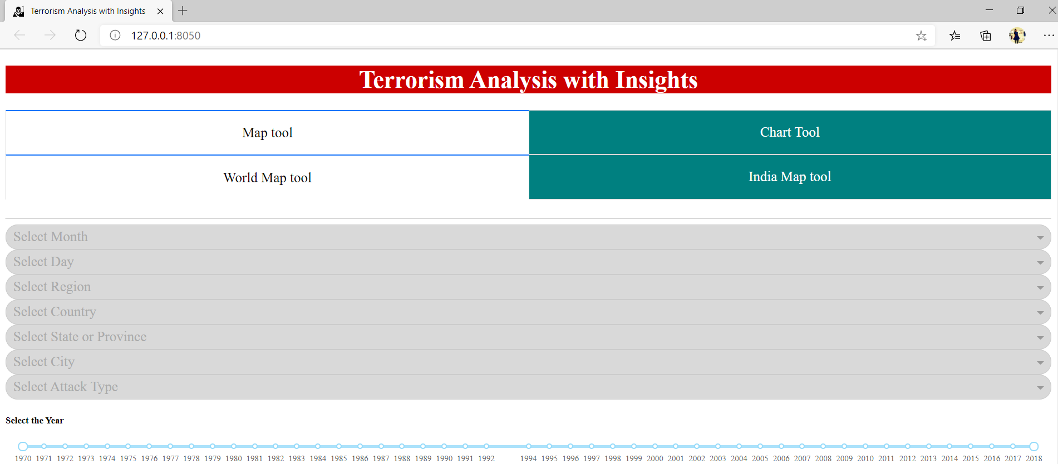

1. **Select the value from dropdown for Month,Date,Region,Country,State,Attack type after filter the data**

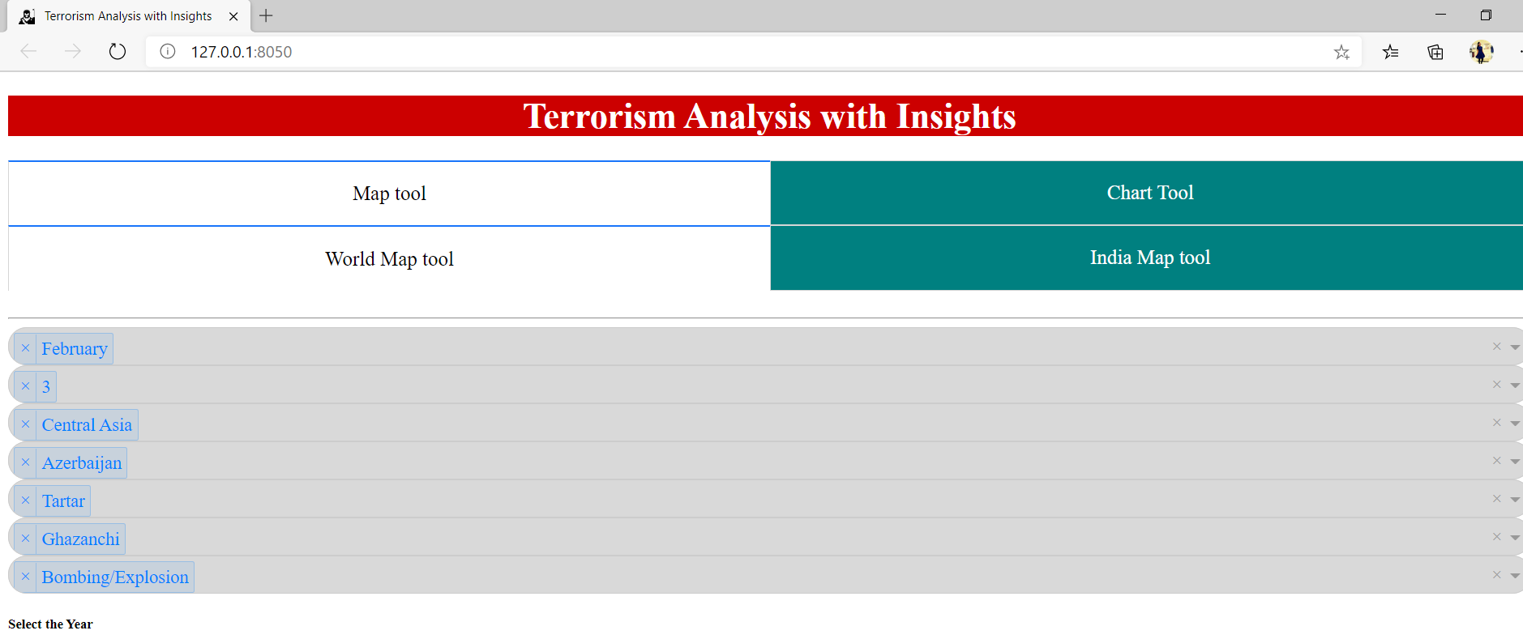

3.Upload world map with attack type legend.

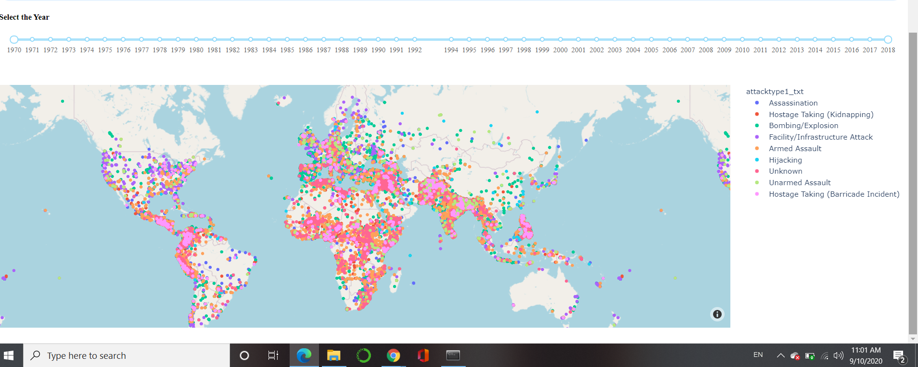

4. World Map change with selected data with multiple values or only India data map with disble value of region and country India.

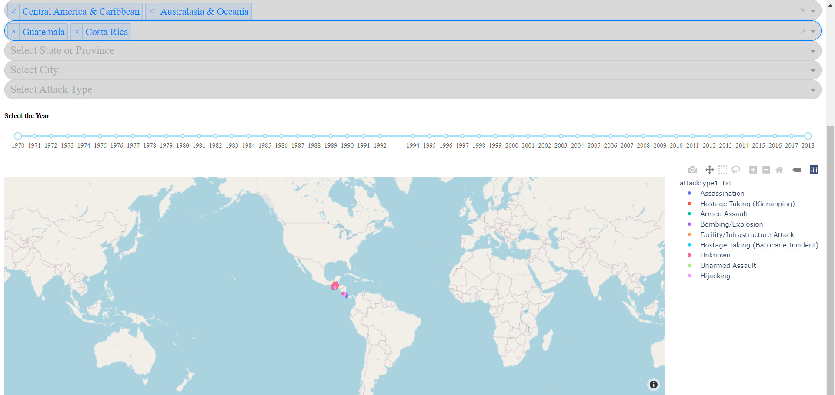

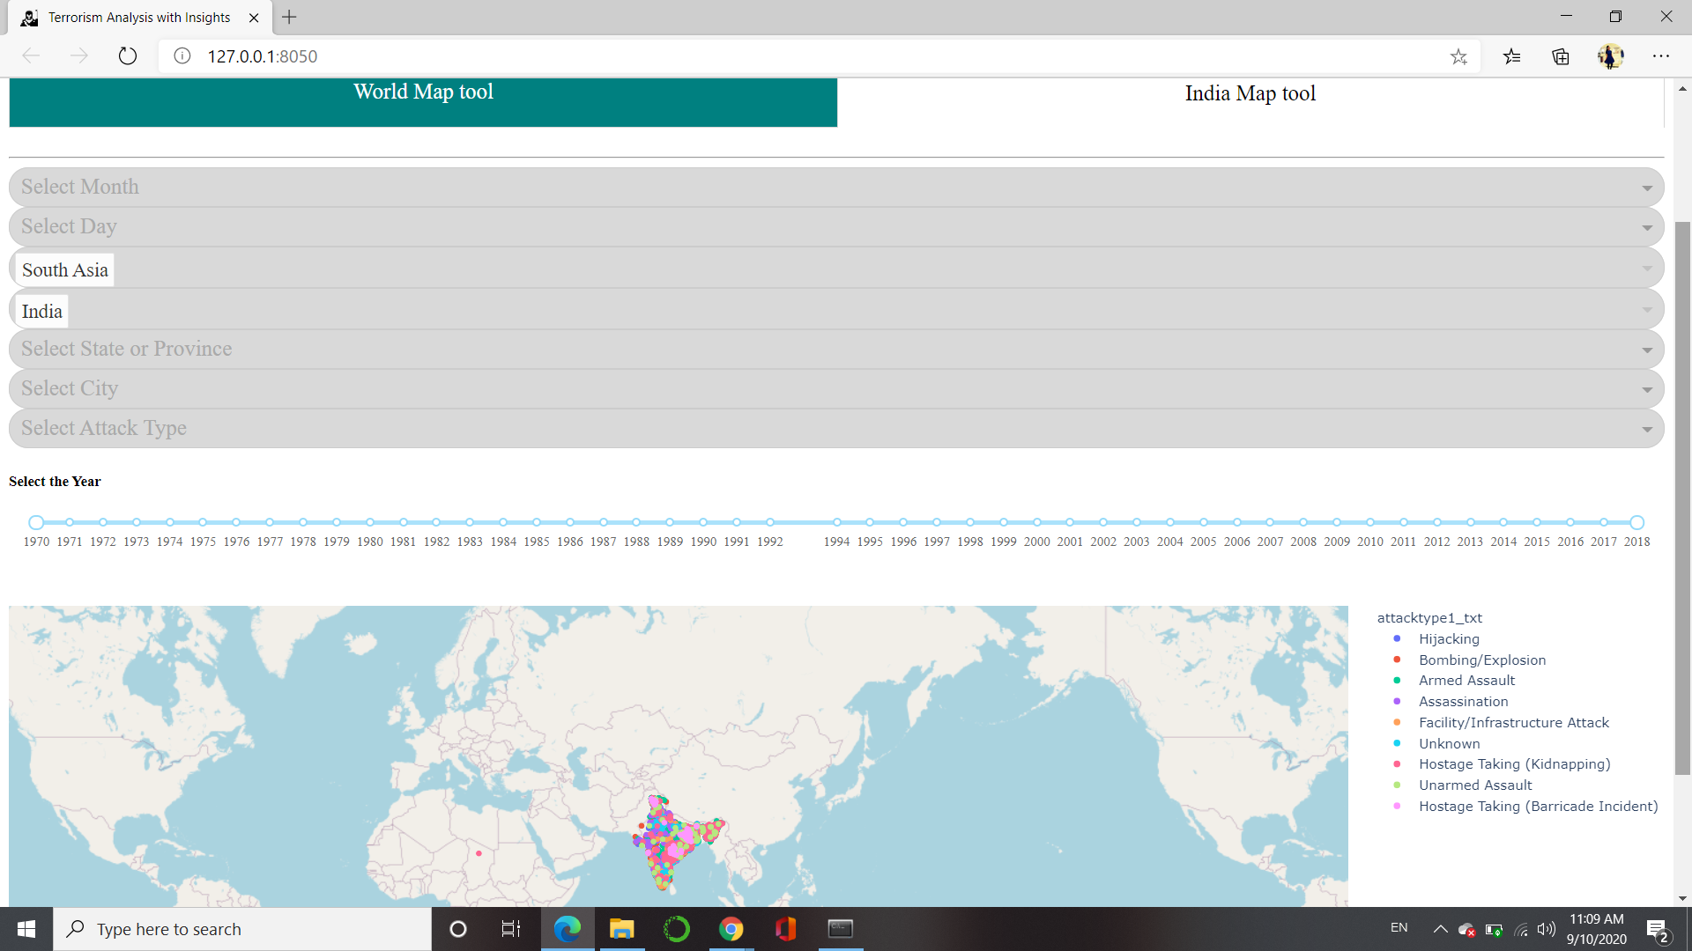

5. Upload the world graph and than graph with search value

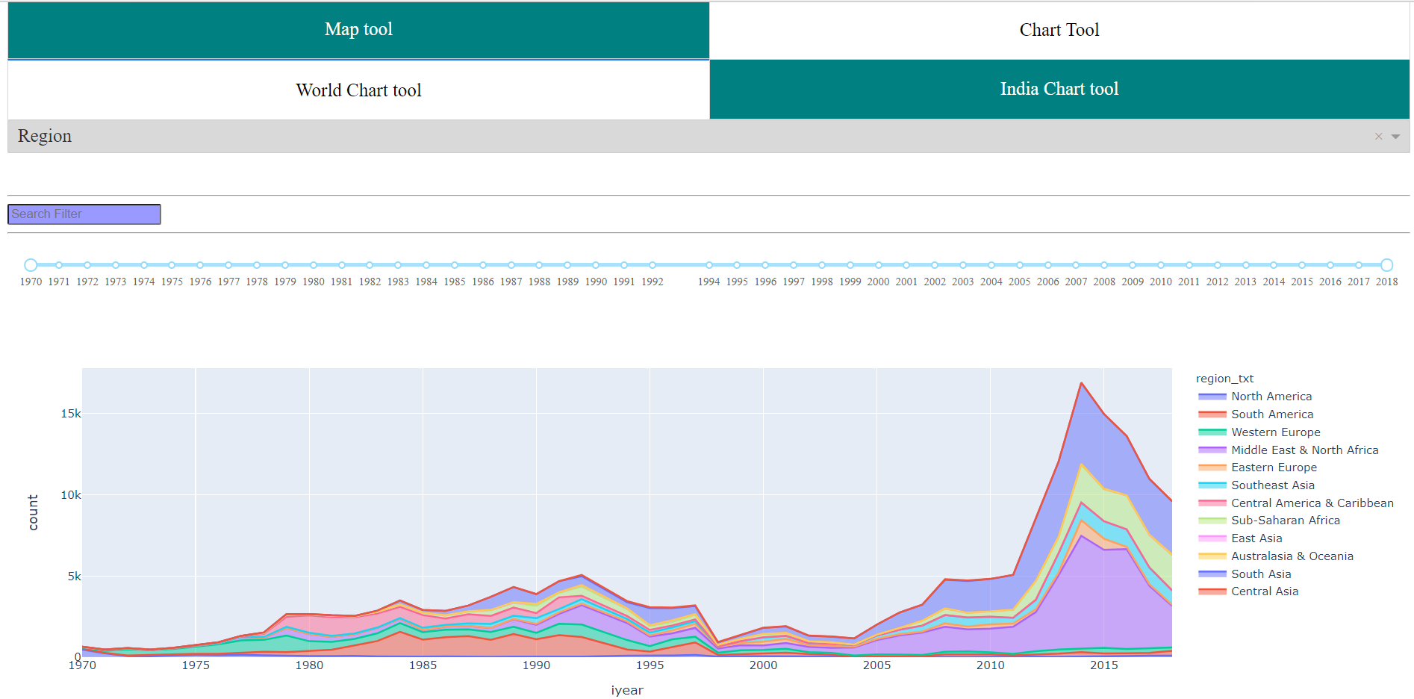

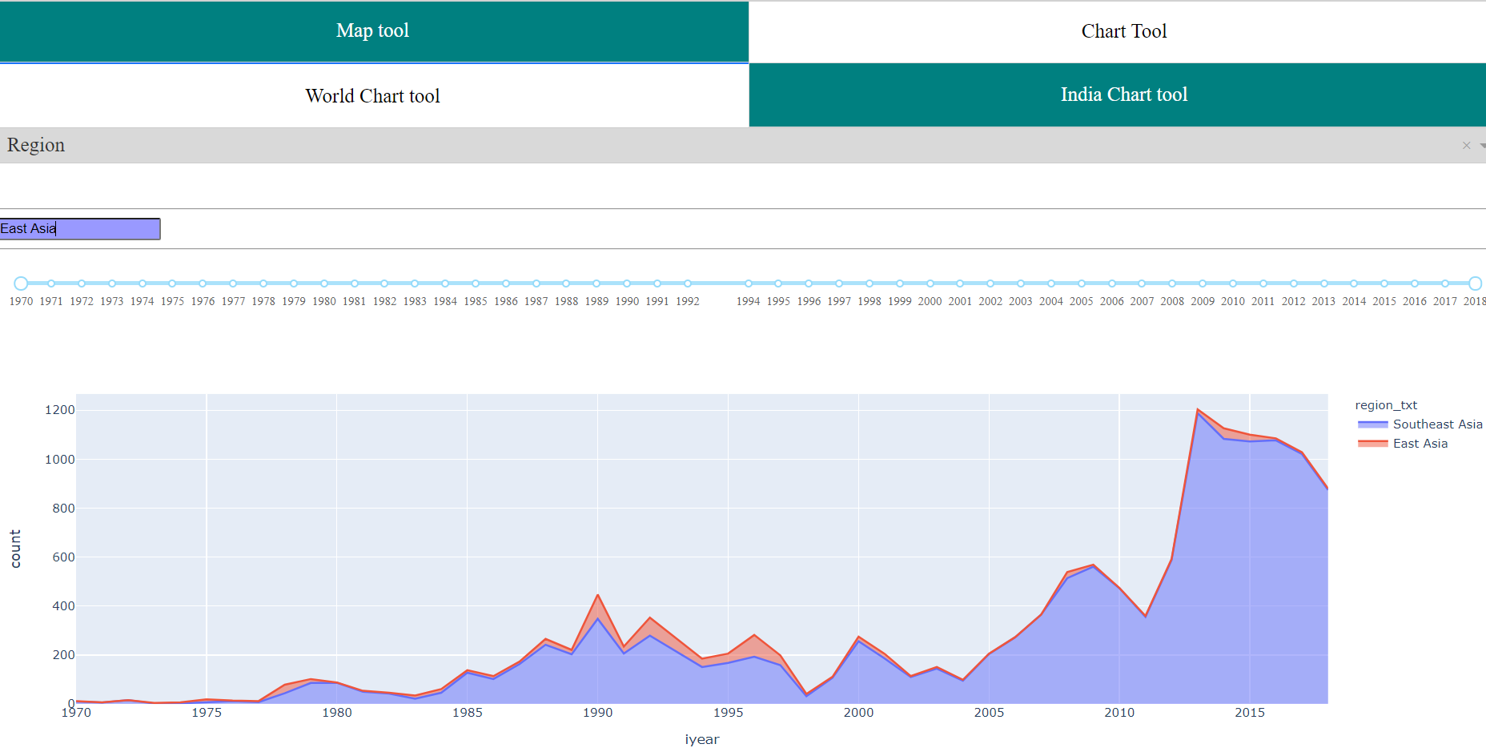

6. India graph with default region and country value

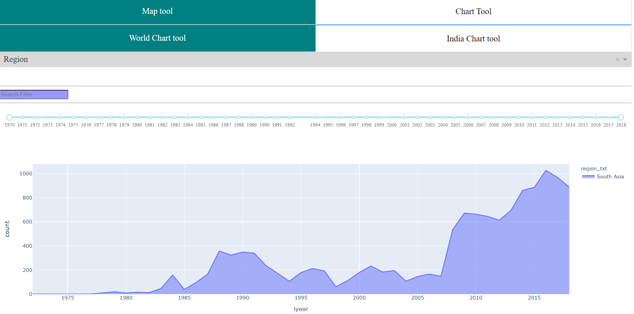

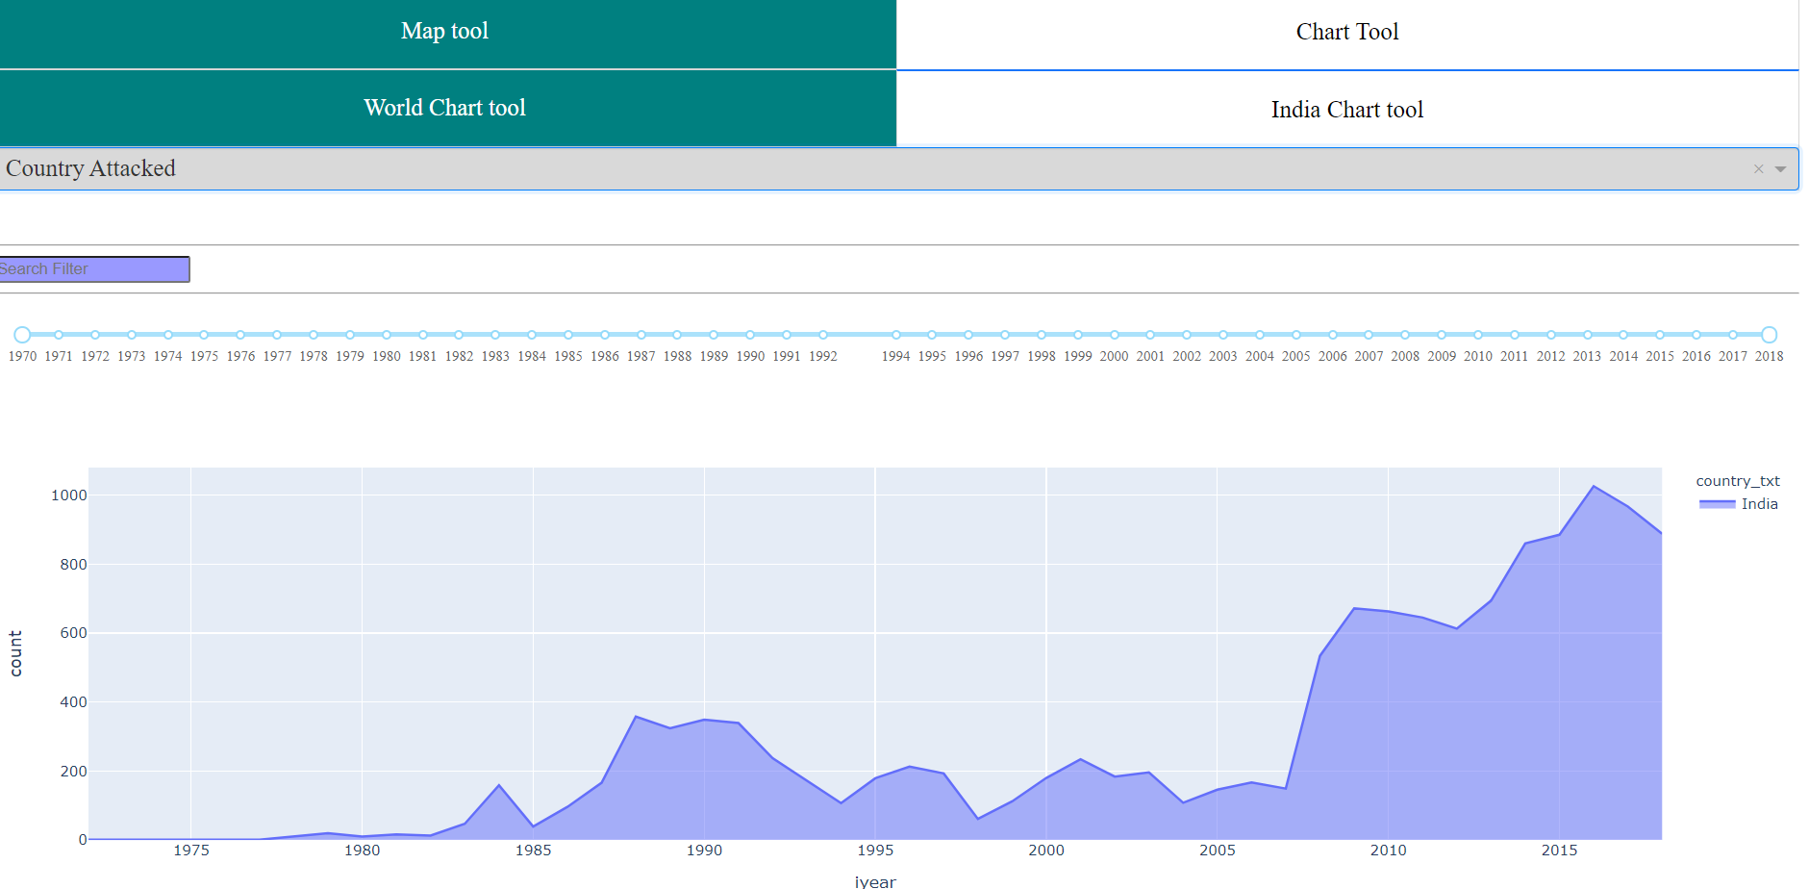

7. Different group type graphs and changes in slider year show according to that graph also change.

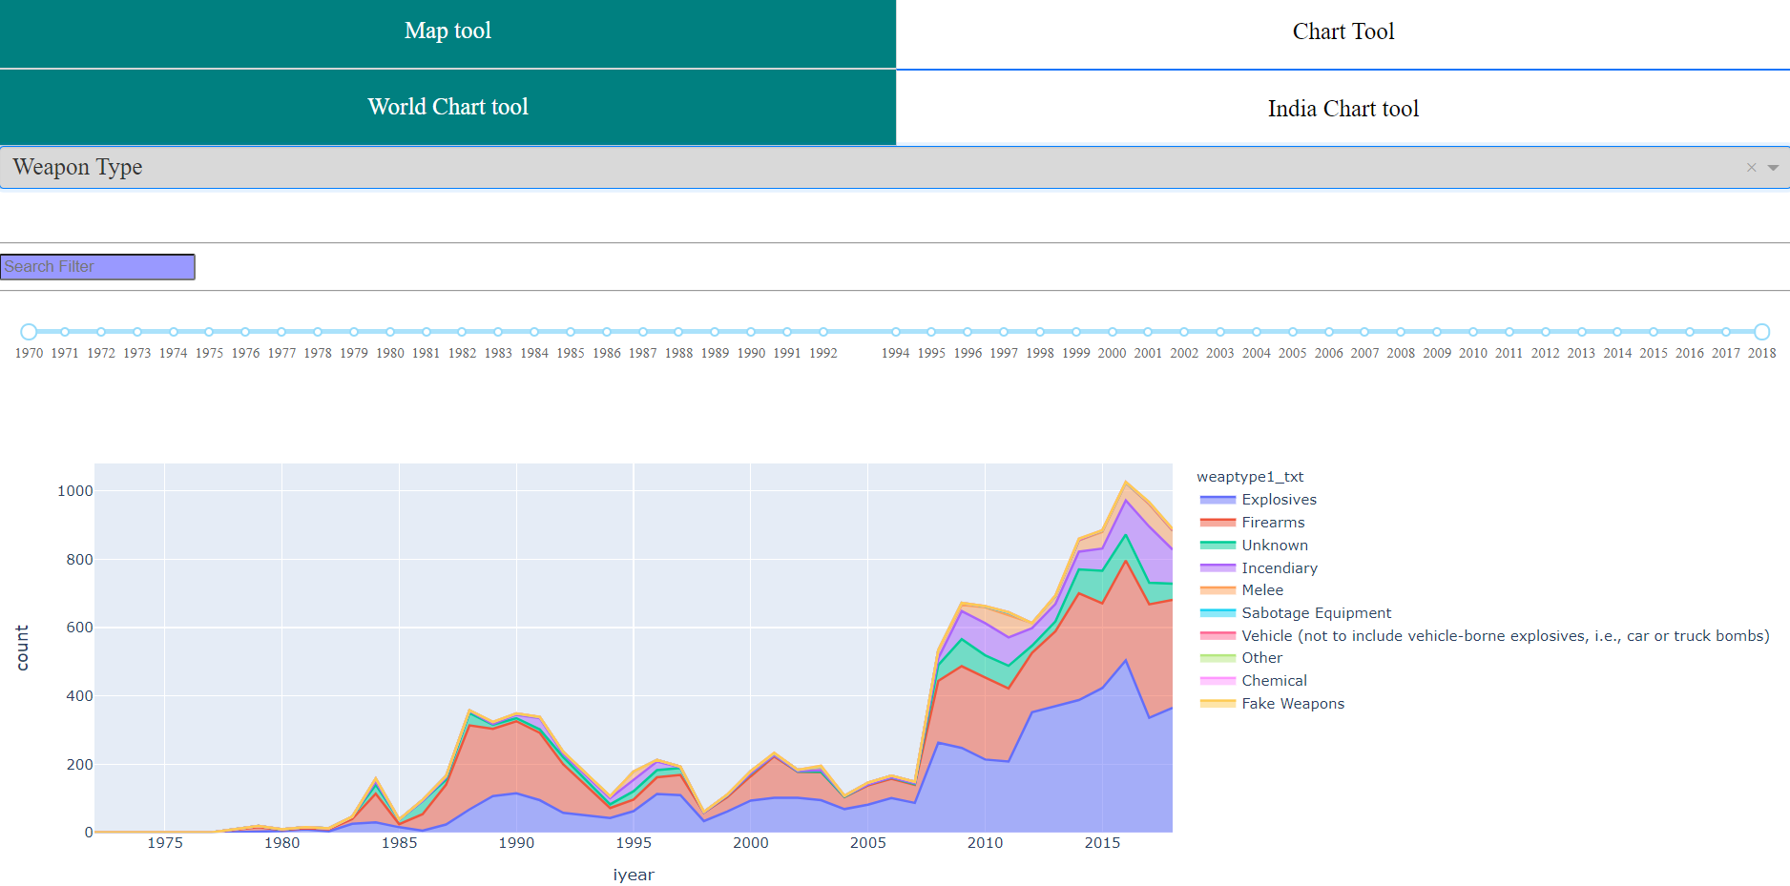

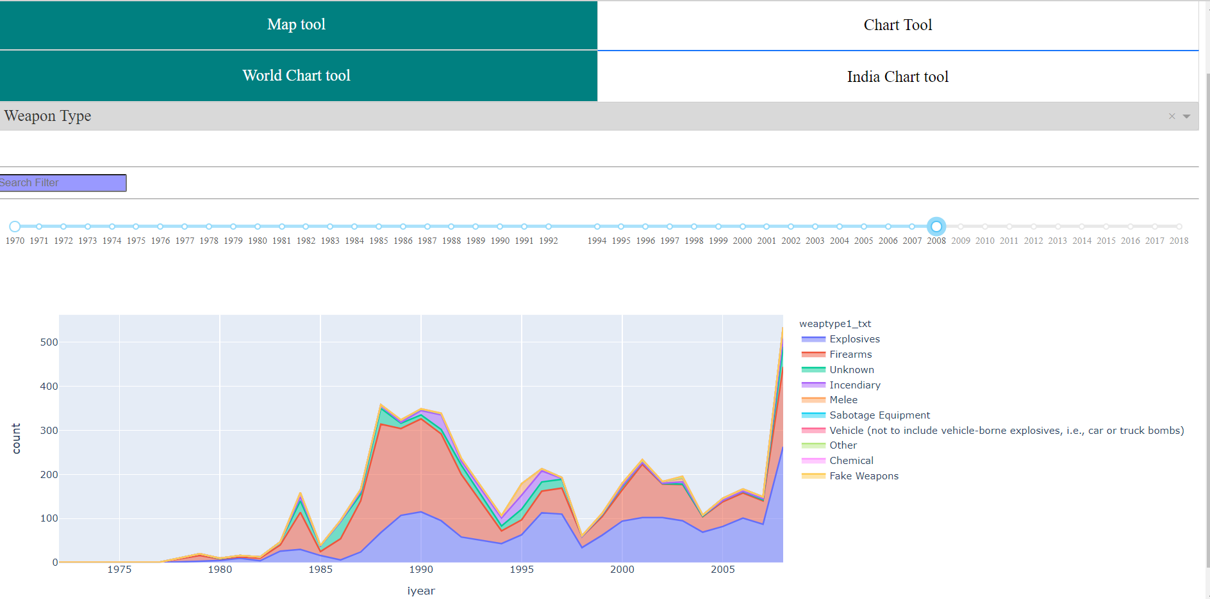

**Conclusion**

Finally I complete my project with the coding and necessary thinking which requirements for completing the project like when I run my code from command it opens itself in a web browser and I am also able to select multiple values from drop down and show the change in map.also get the india map.next i also shown the world graph with different group like country attack,weapon type ect.and also search for the selected group.also able to only south asia and India particular graph and change in slider give also that change in graph.

# 

# 

# **Acknowledgements**

I am highly indebted to project Guide Dr. Sylvester Fernandes and Forsk Coding School for their guidance and supervision as well as for providing necessary information regarding the project & also for their support in completing the project.They devoted their valuable time for each of my queries and encouraged me in each step of work.

I would like to express my gratitude towards my parents & family members for their kind cooperation and encouragement which helped me in completion of this project.

My thanks and appreciations also go to my colleagues in developing the project and people who have willingly helped me out with their abilities.

Thank you,

Vedhas Kharche

**References**

1. Dash.plotly.com
2. https://towardsdatascience.com/how-to-build-a-complex-reporting-dashboard-using-dash -and-plotl-4f4257c18a7f 3.
3. https://www.youtube.com/watch?v=Ldp3RmUxtOQ&list=PLC ERj-IUIFCaELQ2i7AwgD2 M6Xvc4Slf
4. https://towardsdatascience.com/how-to-build-a-web-based-app-in-50-lines-of-code-using -plotly-and-dash-3953f039b217
5. https://youtu.be/GyMO9WCEheQ
6. https://youtu.be/Vn4y9OiJQsc
7. https://youtu.be/i4yJi-cpwWk https://realpython.com/pyinstaller-python/
8. https://youtu.be/yfWJXkySfe0
9. https://youtu.be/lu0PtsMor4E
10. <http://melbourne.pyladies.com/dash-app-basics/>
11. https://dash.plotly.com/layout

**Biography**

My name is Bijal Patel.I live in Gandhinagar ,Gujarat.I am completing my schooling from gandhinagar.recently I completed my M.Sc in physics from Institute of Advanced Research,Gandhinagar.my father has a government job and my mother is a housewife.I have done the my project in plasma,but this project has been one of great project for me because it is out of my field and i have great experience with this project and main i teach many things with doing this project.so thank you forsk coding school given this great opportunity and learn how to handle project requirements by making steps.

Thank you so much